
COMSATS University Islamabad
Islamabad Campus
ECE 6B
Subject: Data Communications & Computer Networks Marks: 20
Exam: Lab Sessional-1 Time: 60 Minutes
Instructor Asad Ali Malik Dated:1st April 1, 2021

Topology Diagram

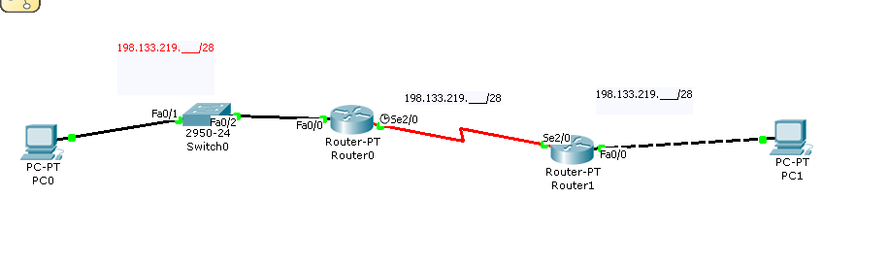
Given an IP address of 198.133.X.0/24 (‘X’ will be registration number of each student, e.g, if reg no. is FA16-ECE-102 the X will be 102), with 4 bits borrowed for subnets, fill in the following information in the table below. (Hint: fill in first three and last)
# | Subnet | First host address | Last host address | Broadcast Address
1
2
3
Last
Addressing table
Device | Interface | Ip Address | Subnet Mask | Default Gateway
R1 | Fast Ethernet |  | 255.255.255.240 | N/A
R1 | Serial interface |  | 255.255.255.240 | N/A
R2 | Fast Ethernet |  | 255.255.255.240 | N/A
R2 | Serial interface |  | 255.255.255.240 | N/A
PC 1 | N/A |  | 255.255.255.240
PC 2 | N/A |  | 255.255.255.240

Tasks
- Implement above network in Packet Tracer
- Perform basic configuration tasks on each router
- Configure and activate Ethernet interfaces
- Ping PC0 to PC1 and vise versa.
Email the results of screen shots after Ping to and from each PC inlcluding ‘the show ip interface brief command’ and running configuration results in this word file (after completing both tables) on asadalimalik@comsats.edu.pk. Email subject will be ‘DCCN Lab Sessional-1’ and file name will be the each student’s registration number.

. DIAGRAM:
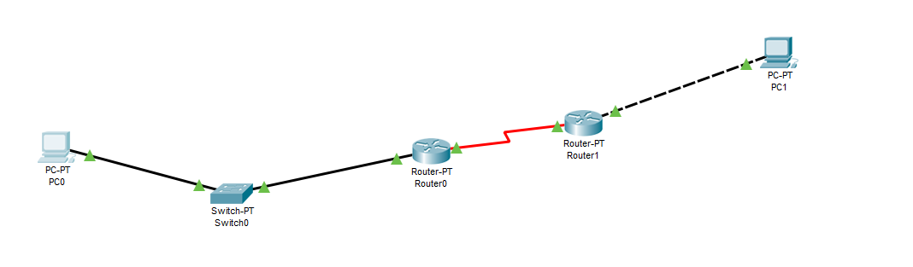

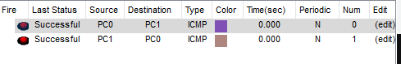

Router 1:
Show ip route:
Router#show ip route
Codes: C - connected, S - static, I - IGRP, R - RIP, M - mobile, B - BGP
D - EIGRP, EX - EIGRP external, O - OSPF, IA - OSPF inter area
N1 - OSPF NSSA external type 1, N2 - OSPF NSSA external type 2
E1 - OSPF external type 1, E2 - OSPF external type 2, E - EGP
i - IS-IS, L1 - IS-IS level-1, L2 - IS-IS level-2, ia - IS-IS inter area
* - candidate default, U - per-user static route, o - ODR
P - periodic downloaded static route

Gateway of last resort is not set

198.133.58.0/28 is subnetted, 3 subnets
C 198.133.58.0 is directly connected, FastEthernet0/0
C 198.133.58.16 is directly connected, Serial2/0
S 198.133.58.32 is directly connected, Serial2/0
198.133.90.0/28 is subnetted, 1 subnets
S 198.133.90.32 is directly connected, Serial2/0

Show running-config
Router#show running-config
Building configuration...

Current configuration : 850 bytes
!
version 12.2
no service timestamps log datetime msec
no service timestamps debug datetime msec
no service password-encryption
!
hostname Router
!
!
!
!
!
!
!
!
ip cef
no ipv6 cef
!
!
!
!
!
!
!
!
!
!
!
!
!
!
!
!
!
!
interface FastEthernet0/0
ip address 198.133.58.3 255.255.255.240
duplex auto
speed auto
!
interface FastEthernet1/0
no ip address
duplex auto
speed auto
shutdown
!
interface Serial2/0
ip address 198.133.58.17 255.255.255.240
clock rate 64000
!
interface Serial3/0
no ip address
shutdown
!
interface FastEthernet4/0
no ip address
shutdown
!
interface FastEthernet5/0
no ip address
shutdown
!
router rip
!
ip classless
ip route 198.133.90.32 255.255.255.240 Serial2/0
ip route 198.133.58.32 255.255.255.240 Serial2/0
!
ip flow-export version 9
!
!
!
!
!
!
!
!
line con 0
!
line aux 0
!
line vty 0 4
login
!
!
!
end

Router 2:

Show ip route:

Router#show ip route
Codes: C - connected, S - static, I - IGRP, R - RIP, M - mobile, B - BGP
D - EIGRP, EX - EIGRP external, O - OSPF, IA - OSPF inter area
N1 - OSPF NSSA external type 1, N2 - OSPF NSSA external type 2
E1 - OSPF external type 1, E2 - OSPF external type 2, E - EGP
i - IS-IS, L1 - IS-IS level-1, L2 - IS-IS level-2, ia - IS-IS inter area
* - candidate default, U - per-user static route, o - ODR
P - periodic downloaded static route

Gateway of last resort is not set

198.133.58.0/28 is subnetted, 3 subnets
S 198.133.58.0 is directly connected, Serial2/0
C 198.133.58.16 is directly connected, Serial2/0
C 198.133.58.32 is directly connected, FastEthernet0/0
198.133.90.0/28 is subnetted, 1 subnets
S 198.133.90.0 is directly connected, Serial2/0

Router#

Show running config:
Router#show running-config
Building configuration...

Current configuration : 818 bytes
!
version 12.2
no service timestamps log datetime msec
no service timestamps debug datetime msec
no service password-encryption
!
hostname Router
!
!
!
!
!
!
!
!
ip cef
no ipv6 cef
!
!
!
!
!
!
!
!
!
!
!
!
!
!
!
!
!
!
interface FastEthernet0/0
ip address 198.133.58.35 255.255.255.240
duplex auto
speed auto
!
interface FastEthernet1/0
no ip address
duplex auto
speed auto
shutdown
!
interface Serial2/0
ip address 198.133.58.18 255.255.255.240
!
interface Serial3/0
no ip address
shutdown
!
interface FastEthernet4/0
no ip address
shutdown
!
interface FastEthernet5/0
no ip address
shutdown
!
ip classless
ip route 198.133.90.0 255.255.255.240 Serial2/0
ip route 198.133.58.0 255.255.255.240 Serial2/0
!
ip flow-export version 9
!
!
!
!
!
!
!
!
line con 0
!
line aux 0
!
line vty 0 4
login
!
!
!
end

___________________________

